**“Web Design Based College Website”**



Project Group Member Name :-

1. **Gaykhe Shubham Gangaram (PRN: 1102108178)**
2. **Gund Payal Balasaheb (PRN:1102108202)**







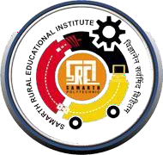

**A**

**Project Report on**

**“Web Design Based College Website”**

**Submitted in Partial fulfilment for the award of the degree of “T.Y. B.Sc. (Computer Science)”**

**Submitted By:**

**1) Gaykhe Shubham Gangaram (PRN:1102108178 )**

**2) Gund Payal Balasaheb (PRN: 1102108202)**



**As**



**Savitribai Phule Pune University, Pune**

Academic Year 2023-2024











Department of Computer Science

**This is to certify that**

**Gaykhe Shubham Gangaram (PRN:1102108178)**

**Gund Payal Balasaheb (PRN: 1102108202) Students of T. Y. B.Sc. (Computer Science)**

**Has completed the project titled**

**“Web Design Based College Website”**

**As per laid down by the Savitribai Phule Pune University, Pune during Academic Year 2023-24**

|  |  |  |
| --- | --- | --- |
| **Internal Examiner** | **External Examiner** | **Project Guide** |
|  |  | **(Prof: Waghole V.V)** |
| **HOD**  **(Prof: Kashid P.R)** |  | **Principal**  **(Prof: Shelar U.B)** |

# Acknowledgement

I would like to take this opportunity to express my heartfelt thanks to my guide of computer science Prof. Waghole V.V for his esteemed guidance and encouragement, especially through difficult times. His suggestions broaden my vision and guided me to succeed in this work. I am also very grateful for his guidance and comments while designing part of my project and learnt many things under his leadership.

Also, I would like to thank all my teaching and non-teaching staff of our BCS department, especially Miss Nimase.U. R and Prof. Maniyar.S.A. for their encouragement and suggestions. My sincere thanks to all my friends who helped me directly or indirectly in completing this project work. I would like to express my appreciation for the wonderful experience during the completion of this project work.

**Submitted By**: **Gaykhe Shubham Gangaram (PRN: 1102108178)**

**Gund Payal Balasaheb (PRN: 1102108202)**

# Table of Contents

|  |  |  |
| --- | --- | --- |
| **Sr. No** | **Title** | **Page No** |
| 1 | Abstract of project | 2 |
|  | 1.1 Introduction   * 1. Background   2. Objectives   3. Purpose, Scope   4. Existing System   5. proposed System | 3 |
| 3 |
| 4 |
| 4 |
| 5 |
| 5 |
| 2 | Requirement and Analysis | 6 |
|  | * 1. Problem Definition   2. Requirement Specification   3. System Analysis | 6 |
| 6 |
| 8 |
| 3 | System Design | 12 |
|  | 3.1 ER Diagram One to many relation | 12 |
| 3.2 Activity Diagram | 13 |
| 3.3 Class Diagram | 14 |
| 3.4 Use Case Diagram | 15 |
| 3.5 Sequence Diagram | 16 |
| 3.6 Data Flow Diagram | 17 |
| 3.7 Component Diagram | 20 |
| 3.8 Deployment Diagram | 21 |
| 3.9 Advantages and Disadvantages | 22 |
| 4 | Outputs And Report Testing | 24-31 |
| 5 | Conclusion | 32 |
| 6 | Future Scope | 33 |
| 7 | Reference and Bibliography | 34 |

1. **ABSTRACT OF PROJECT**

We are going to make the college's related website which will provide all information regarding our colleges. Now it is of vital thing in present scenario of any college where student can get all information before taking admission. This site provides the all information like student can easily get all information regarding their syllabus, especially for the training and placement since it is difficult to get the students informed during the campus so all the students can easily get information. There is also facility for the faculty members, they can easily give all the answer of student's question and can give their solution of problem.

## INTRODUCTION

Welcome to our college website! Here, you'll find a plethora of valuable resources and information tailored to enhance your college experience. Explore our intuitive menu featuring sections like:

Home: Discover an introduction to our college, find contact information, and feel free to ask any questions you may have.

About Us: Gain insights into our institution's history, mission, and values.

Admissions: Access information on admission procedures, eligibility criteria, and application forms.

Student Portal: Seamlessly navigate through your student account, accessing features such as course registration, grades, and academic resources.

Academics: Explore our diverse range of programs, curriculum details, and academic calendars.

Placement: Learn about our robust training programs and career placement opportunities, ensuring your professional success.

Events and News: Stay updated on the latest happenings, events, and news within our college community.

Library: Browse our extensive collection of books, authored by subject experts, and stay informed about library activities and resources.

Staff Portal: Dedicated login for staff members to access administrative tools and resources.

## BACKGROUND

In the digital age, a college website serves as the virtual gateway to an institution, acting as the primary point of contact for prospective students, current attendees, faculty, alumni, and stakeholders. The design and functionality of a college website play a pivotal role in shaping the perception of the institution, facilitating communication, and enhancing user experience. To achieve these objectives, it is imperative to adopt a comprehensive background theory concept that encompasses various principles of web design, user experience (UX), and information architecture.

Understanding the diverse needs and preferences of users is paramount in designing a college website. Conducting user research, surveys, and usability testing helps in gaining insights into user behavior, preferences, and pain points.

Employing user personas and journey mapping aids in creating intuitive navigation pathways and personalized experiences tailored to different user segments, such as prospective students, current students, faculty, and alumni.

## OBJECTIVES

Implement interactive features such as discussion forums, and virtual events to facilitate real-time communication and collaboration among students, faculty, alumni, and administrators.Integrate social media integration tools to promote community engagement and interaction, enabling users to share content, participate in discussions, and stay connected with the college community across various social platforms.

Integrate student information systems, learning management systems, and other institutional platforms to provide seamless access to academic resources, course materials, grades, and administrative services.Enable single sign-on functionality and API integrations with third-party applications to streamline authentication processes and enhance user convenience.

Establish mechanisms for gathering user feedback, suggestions, and feature requests to iteratively improve the website's functionality, usability, and overall user experience.

Conduct regular usability testing, surveys, and focus groups to identify pain points, address usability issues, and prioritize feature enhancements based on user feedback.

## PURPOSE, SCOPE

**Purpose:**

The primary purpose of creating a college website using HTML and CSS is to establish an online presence for the institution and provide a centralized platform for sharing essential information with students, faculty, staff, and prospective applicants.

The website serves as a repository of information about the college, including its history, mission, academic programs, faculty profiles, admission requirements, and campus facilities.

The website offers access to important resources for students, such as course schedules, syllabi, assignment submissions, academic calendars, and campus policies.

Ensuring that the website is accessible to all users, including those with disabilities, by adhering to web accessibility standards and providing alternative text for images, keyboard navigation, and clear navigation pathways.

## Scope:

The objective of this project is to create a simple college website. The website will serve as an informational platform for students, faculty, prospective students, and other stakeholders to learn about the college, its programs, and services.

* Display basic information about the college, such as its name, logo, and a brief introduction.
* Include navigation links to different sections of the website.
* Provide detailed information about the college's history, mission, vision, and values.
* Highlight key achievements, awards, and recognitions.
* Feature profiles of faculty members and administrative staff.
* Include photos, biographies, and contact information for each staff member.

## Existing System:

Explore our dynamic college website, offering comprehensive information about our programs, faculty, and campus life, with intuitive navigation and responsive design for seamless browsing.

## Supported Tasks:

Show college facility.

Display the information about Students and Teachers.

Give the basic idea about the college campus.

Display the view of the college.

Give information about department of the college.

## Proposed System:

Experience seamless navigation and easy access to essential college information with our website, featuring responsive design, intuitive interface, and comprehensive sections for academics, admissions, faculty profiles, and campus life.

## Supported Tasks:

Show latest college facility.

Display the details information about Teachers which are helpful for take admission.

Give the detailed and latest idea about the college campus.

Display and explore the view of the college.

Show the latest news and event of the college.

Give information about department of the college.

Display the placement student information.

Also show the student’s parent review about college.

# REQUIREMENT AND ANALYSIS

Website analysis is the process of comprehensively understanding existing systems and identifying their deficiencies. The solution is determined to address issues in the proposed system, which defines the system. The website is divided into smaller parts, and the functions and interrelation of these modules are studied during the system analysis.

## Problem Definition:

The problem definition for the college website revolves around addressing the inefficiencies and shortcomings of the existing digital platform. Currently, the website lacks intuitive navigation, making it challenging for users to access crucial information about academics, admissions, faculty profiles, and campus life. Additionally, the website's design is outdated and non-responsive, leading to a poor user experience across various devices. There is also a lack of personalized features, hindering engagement and interaction among students, faculty, and alumni. Moreover, the absence of accessibility measures poses barriers for users with disabilities, limiting their ability to navigate and utilize the website effectively. Furthermore, the website fails to incorporate real-time updates and interactive elements, diminishing its relevance and appeal to the college community. In essence, the problem lies in the website's inability to effectively serve as a comprehensive and user-friendly platform for communication, information dissemination, and community engagement within the college ecosystem.

The problem statement for the college website centers on the need to overhaul its existing digital infrastructure to address several key deficiencies. Primarily, the website lacks intuitive navigation and organization, making it difficult for users to access essential information regarding academics, admissions, faculty, and campus life. Furthermore, the website's outdated design and lack of responsiveness result in a subpar user experience across various devices, hindering engagement and interaction. Additionally, the absence of personalized features and interactive elements limits user engagement and fails to foster a sense of community among students, faculty, and alumni. Moreover, the website's lack of accessibility measures poses barriers for users with disabilities, impeding their ability to navigate and utilize the platform effectively. Overall, the problem lies in the website's failure to effectively serve as a user-friendly and inclusive hub for communication, information dissemination, and community engagement within the college ecosystem.

## Requirement Specification:

The website shall feature intuitive navigation menus with clear labels for easy access to different sections, including Home, About Us, Academics, Admissions, Faculty and Staff, Campus Life, Events, and Contact Us. Each section shall provide detailed information relevant to its category, such as the college's history, mission, academic programs, admission procedures, faculty profiles, campus facilities, upcoming events, and contact details. The website shall incorporate a search functionality allowing users to quickly find specific information or resources within the website. It shall include interactive features such as forms for admissions inquiries, event registrations, and feedback submissions. The website shall be accessible across various devices and screen sizes, ensuring a seamless user experience on desktops, laptops, tablets, and smartphones. Accessibility standards shall be implemented to ensure compliance with WCAG (Web Content Accessibility Guidelines), enabling users with disabilities to navigate and utilize the website effectively. The website shall support multi-language functionality to cater to the diverse linguistic backgrounds of the college community.

The website shall have a visually appealing and modern design that reflects the college's brand identity and values. It shall load quickly and efficiently, minimizing page load times to enhance user experience. The website shall be secure, utilizing HTTPS protocol, SSL certificates, and encryption mechanisms to protect user data and maintain privacy. Regular backups shall be implemented to prevent data loss and ensure the website's continuity in case of technical issues or server failures. The website shall be hosted on a reliable and scalable web hosting platform to accommodate varying levels of traffic and user interactions. It shall be compatible with popular web browsers such as Google Chrome, Mozilla Firefox, Safari, and Microsoft Edge, ensuring compatibility across different browser environments. The website shall adhere to SEO (Search Engine Optimization) best practices to improve visibility and ranking on search engine results pages.

## Feasibility Study

* + **Technical feasibility:** Technical feasibility for a college website involves assessing whether the proposed project is viable from a technical standpoint. Here are some key technical feasibility considerations for a college website.

Server Infrastructure, Website Development Tools, Responsive Design, Content Management. Additionally, the system requires a steady internet connection, which is typically available in most homes and offices.

* + **Operational feasibility**: The ease of use of the proposed system is evaluated. The website is designed to be simple and accessible for almost everyone, with no special skills required to operate it. Even young children who can the website easily.
  + **Economic feasibility:** The costs and benefits of the proposed system are analyzed. The primary costs are documentation which are relatively low. Maintenance costs for uploading on internet are also projected to be low.
  + **Organizational feasibility:** The project's management and organizational structure are evaluated. As a one-person team, there should be no issues with management, which increases the feasibility of the project.

Overall, the feasibility study indicates that the project's goals are achievable, as the college website is technically feasible with no external hardware requirements, simple to operate, and inexpensive to maintain. Therefore, it is recommended to proceed with the project.

# SYSTEM ANALYSIS

## Hardware Requirements:

* Core i3 Processor
* RAM 512MB or more.

## Software Requirements:

* Windows 8(64-bit) or above.
* Visual code
* Xampp

## Fact Finding Technique:

* The specific methods that are used by analysts to collect or gather the data about requirements from the user, customers or even other stakeholders is called as factfinding techniques.
* Fact finding techniques are used by the system analyst team to know the exact requirements of the customers or users.

## Searching Records:

* Here examination of existing documents, facts and files takes places.
* That is facts from documents, rules and regulations
* and standard operating procedures used in the organization is obtained.

## Interviews:

This was the best technique in which we collected maximum information from individual and from teachers of the college.

## Questionnaires

### User Interaction and Experience:

* How easy is it for users to navigate through the website and find the information they need?
* Is the website accessible to users with disabilities, including those using screen readers or keyboard navigation?
* How does the website perform on mobile devices such as smartphones and tablets?
* Is the content on the website relevant and up-to-date for the target audience?

### Task and Information Management:

* + - * What tasks or activities would you like in the college website?
      * Are there any specific domains or areas of knowledge you would like the college website to be proficient in?
      * How would you like the college website to handle information retrieval and organization?

### Natural Language Understanding:

* What is the location of the college campus?
* Can you provide me with the contact details of the admissions office?
* What are the academic programs offered by the college?
* What are the admission requirements for undergraduate programs?

### Personalization and Adaptability:

* How does the college website personalize the user experience for different stakeholders such as prospective students, current students, faculty, and alumni?
* Are there personalized recommendations or suggestions provided to users based on their browsing history, academic interests, or extracurricular activities?

### Privacy and Data Handling:

* How is user data collected and stored on the college website, and what measures are in place to ensure its privacy and security?
* What types of personal information are collected from website visitors, such as students, faculty, and alumni, and for what purposes?
* Are there mechanisms in place for obtaining consent from users before collecting their personal data, and how is this consent managed and documented?
* How long is user data retained on the website, and what procedures are followed for data retention and deletion?
* How are data breaches or security incidents involving user data addressed and communicated to affected individuals?

### Future Development and Improvement:

* How do you plan to gather feedback from users regarding their experience with the college website, and how will this feedback be utilized for future development and improvement?
* What strategies do you have in place to monitor website analytics and user behavior, and how will this data inform future enhancements and updates to the website?
* In what ways do you envision incorporating emerging technologies, such as AI-powered chatbots or virtual assistants, into the college website to enhance user experience and functionality?
* How do you plan to ensure ongoing accessibility compliance with evolving web standards and regulations, and what measures will be taken to accommodate users with disabilities in future website development?

## Observation:

* + - * **Increasing Demand:** As education undergoes digital transformation, colleges are increasingly adopting online platforms to facilitate communication, information dissemination, and administrative processes. A website serves as a central hub for students, faculty, staff, and other stakeholders to access resources, communicate, and engage with the college community.
      * **Convenience and Efficiency:** The website should have intuitive navigation menus and clear labeling, allowing users to easily find the information they need without getting lost or confused. Implementing a robust search feature enables users to quickly locate specific information or resources within the website, saving time and effort.
      * **User-Friendly Wake Word:** The user-friendly wake word for a college website could be "Campus Connect." This wake word encapsulates the essence of the website, emphasizing connectivity, community, and engagement within the college ecosystem. It resonates well with users by evoking a sense of belonging and fostering interaction with various aspects of campus life, including academics, events, resources, and support services.
      * **Data Availability:** The college website should provide easy access to essential information such as academic programs, admissions criteria, faculty profiles, campus facilities, and contact details. Information should be organized in a logical manner and accessible through intuitive navigation menus, search functionality, and clear links. Ensure that information on the website is kept up-to-date and reflects the current status of programs, events, and services offered by the college. Implement mechanisms for timely updates and revisions to content, such as content management systems (CMS), to ensure accuracy and relevance.

## Future Enhancement:-

* In envisioning the future enhancements of our college website, our focus lies in creating a dynamic digital platform that continuously evolves to meet the evolving needs of our college community. Our roadmap for enhancement is guided by the principles of user-centric design, technological innovation, and continuous improvement.
* Personalized User Experience:

We aim to leverage data-driven insights and analytics to tailor the website experience to the preferences, interests, and needs of individual users. Through personalized recommendations, customized content delivery, and adaptive interfaces, we seek to enhance engagement and satisfaction among students, faculty, staff, alumni, and other stakeholders.

* Integration of Emerging Technologies:

Embracing emerging technologies such as artificial intelligence (AI), machine learning, and natural language processing, we envision incorporating advanced features such as AI-powered chatbots, virtual assistants, and predictive analytics into the website. These innovations will not only streamline user interactions but also provide intelligent insights and recommendations, enhancing the overall user experience.

* Enhanced Accessibility and Inclusivity:

We are committed to ensuring that the website remains accessible and inclusive for users of all abilities. Through ongoing compliance with web accessibility standards such as WCAG (Web Content Accessibility Guidelines), we will implement features such as alternative text for images, keyboard navigation, and screen reader compatibility, ensuring equal access to information for all users.

# SYSTEM DESIGN

## ER DIAGRAM

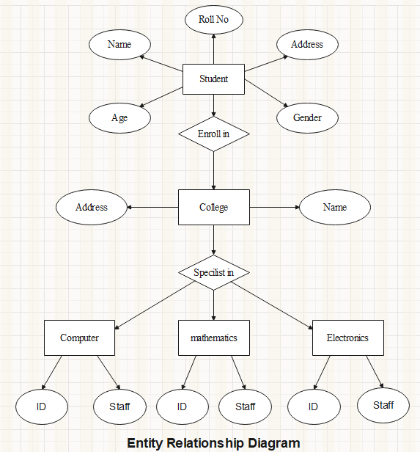

* + - 1. **ACTIVITY DIAGRAM**

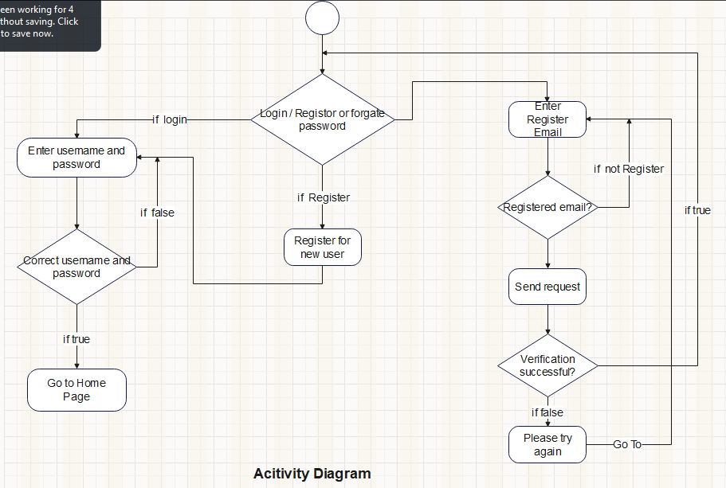

## CLASS DIAGRAM

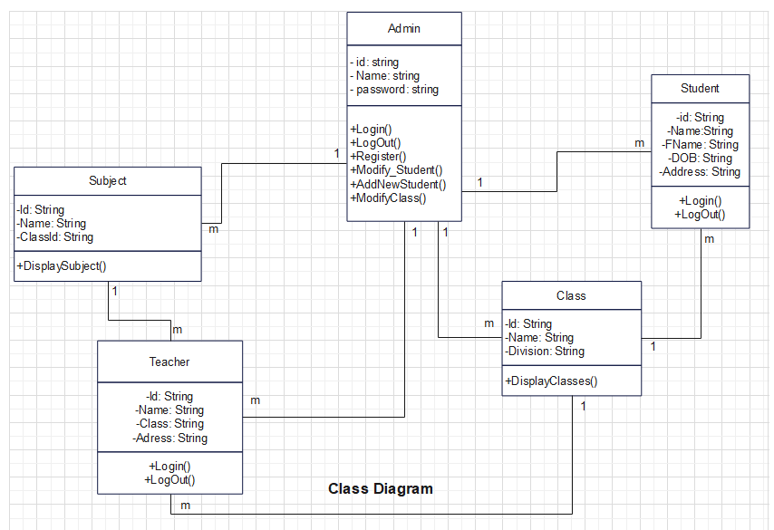

* + - 1. **USE CASE DIAGRAM**

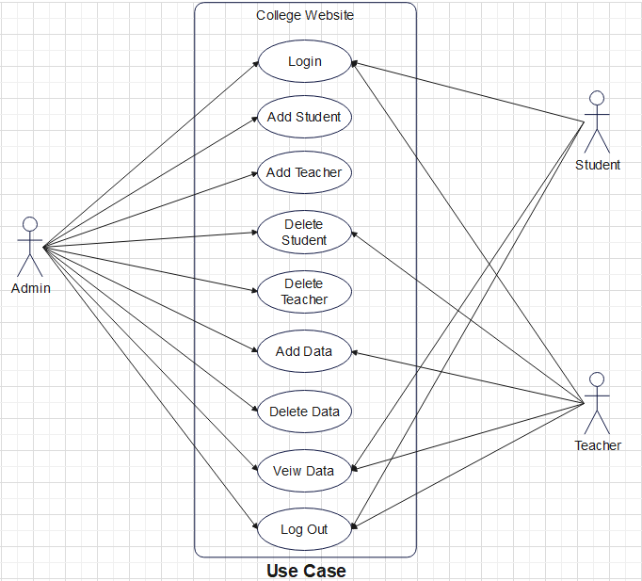

## SEQUENCE DIAGRAM

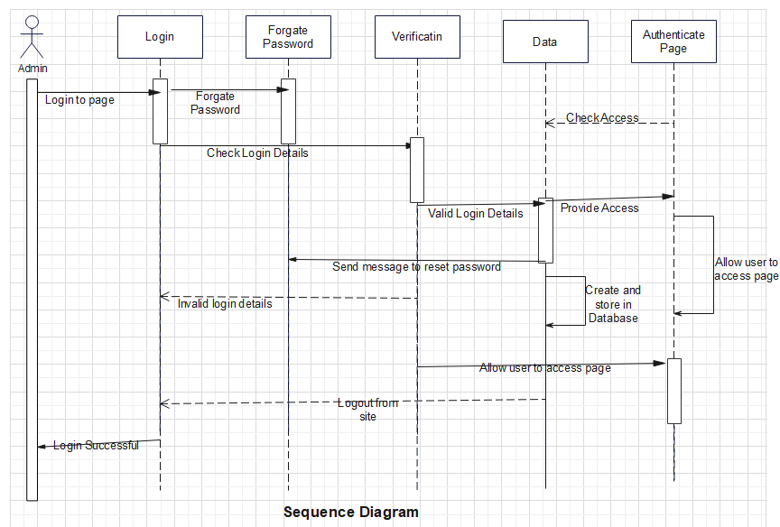

## DATA FLOW DIAGRAM

* + - * 1. **DFD Level 0 (Context Level Diagram)**

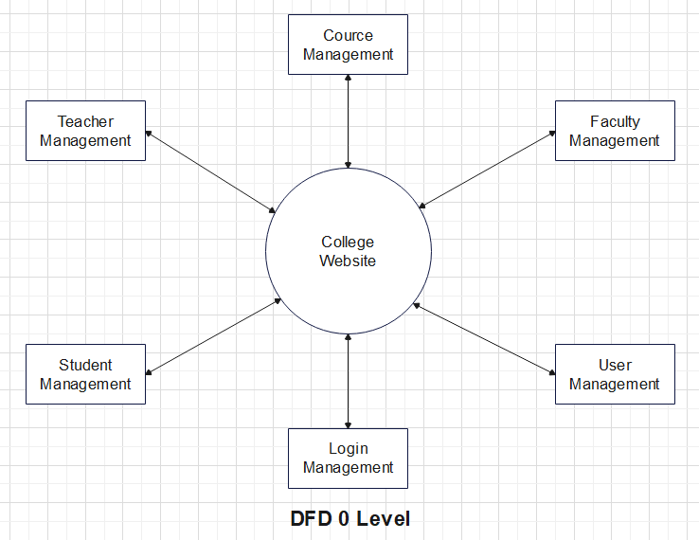

* + - * 1. **DFD Level 1**

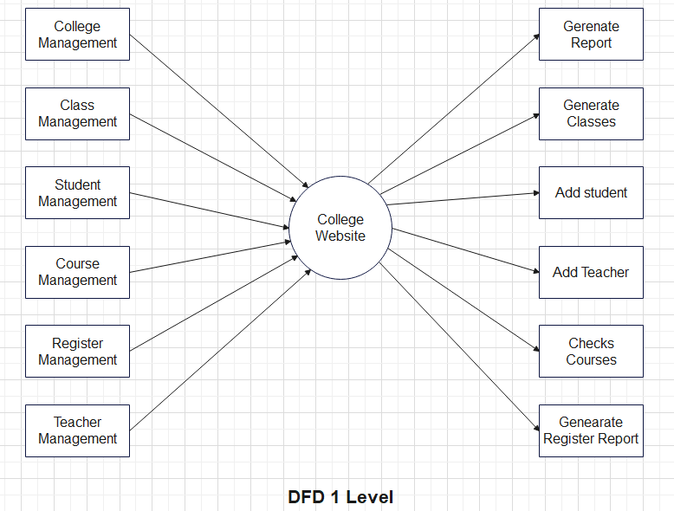

* + - * 1. **DFD Level 2**

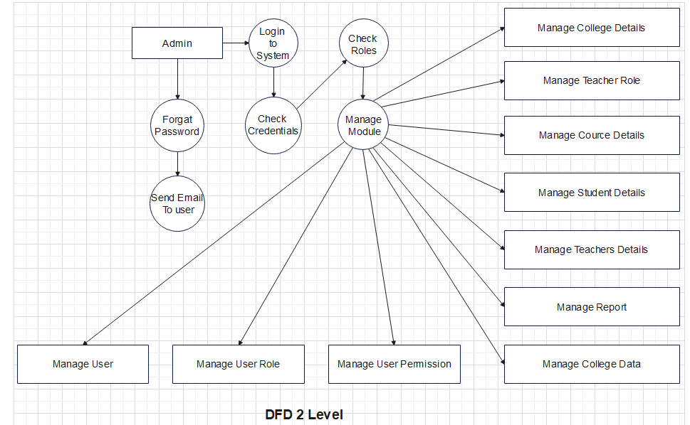

## COMPONENT DIAGRAM

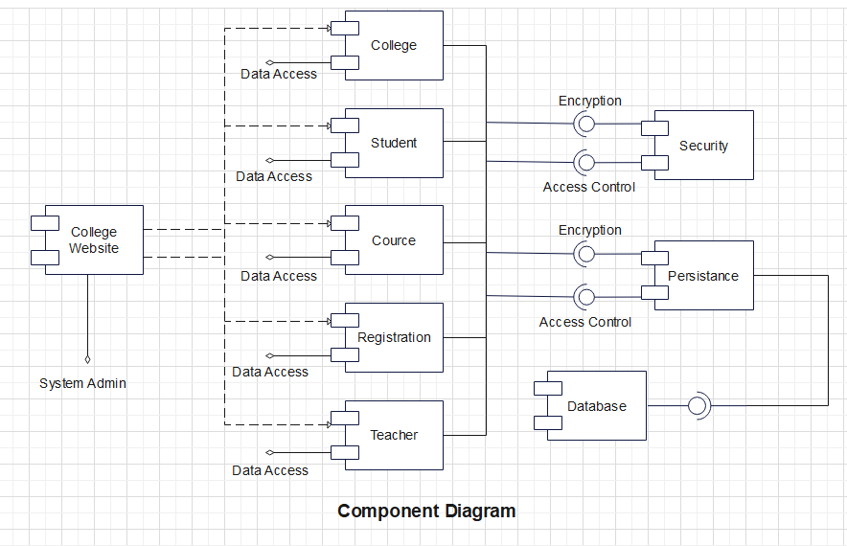

## DEPLOYMENT DIAGRAM

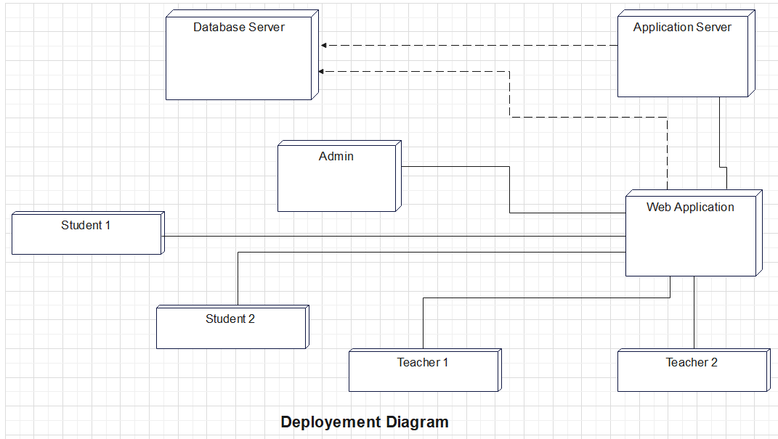

## Advantages and Disadvantages:

**Advantages:**

* Cost-Effectiveness: HTML and CSS are open-source technologies, making them cost-effective options for website development, particularly for educational institutions with limited budgets.
* Ease of Learning and Use: HTML and CSS are relatively easy to learn and use, making them accessible to developers with varying levels of experience. This simplicity also allows for quick prototyping and iteration during the development process.
* Compatibility: Websites built using HTML and CSS are highly compatible across different web browsers, operating systems, and devices, ensuring a consistent user experience for all visitors.
* User-Friendly: HTML provides semantic markup, allowing search engines to easily crawl and index website content. Additionally, CSS can be used to optimize page load times and improve overall performance, contributing to better search engine rankings.
* Customization and Flexibility: HTML and CSS provide developers with full control over the design and layout of the website, allowing for unlimited customization and flexibility to meet the specific needs and preferences of the college.
* Responsive Design: With CSS media queries, developers can create responsive designs that adapt and respond to different screen sizes and devices, ensuring that the website looks and functions optimally on desktops, laptops, tablets, and smartphones.
* Scalability: HTML and CSS allow for modular development, making it easy to scale and expand the website as the college grows and evolves. New pages, features, and functionalities can be seamlessly integrated into the existing website architecture.
* Accessibility: By adhering to web accessibility standards and best practices, developers can ensure that the college website is accessible to users of all abilities, including those with disabilities. HTML provides semantic markup for accessibility, while CSS can be used to enhance readability and usability.

## Disadvantages:

* Limited Interactivity: HTML and CSS are primarily used for creating static web pages, which means that the level of interactivity and dynamic functionality may be limited compared to websites built with more advanced technologies like JavaScript or server-side scripting languages.
* Maintenance Challenges: As the website grows and evolves, maintaining consistency and making updates across all pages can become challenging, especially if changes need to be made to the layout or design. This can result in increased maintenance efforts and potential inconsistencies across different parts of the website.
* Cross-browser Compatibility: Ensuring consistent rendering and functionality across different web browsers can be more challenging when relying solely on HTML and CSS. Some features or styles may behave differently or require additional workarounds to achieve compatibility across various browser versions.
* Limited Functionality: While HTML and CSS are sufficient for creating static web pages and basic styling, they lack the ability to implement more advanced functionalities such as user authentication, database interactions, or dynamic content generation. Integrating such features may require additional technologies or server-side scripting languages.
* Accessibility Challenges: Ensuring full accessibility compliance for users with disabilities may be more difficult when relying solely on HTML and CSS. Certain interactive or dynamic elements may pose accessibility challenges, requiring additional effort to implement alternative solutions or assistive technologies.

# Output and Report Testing

## Output Screenshots:

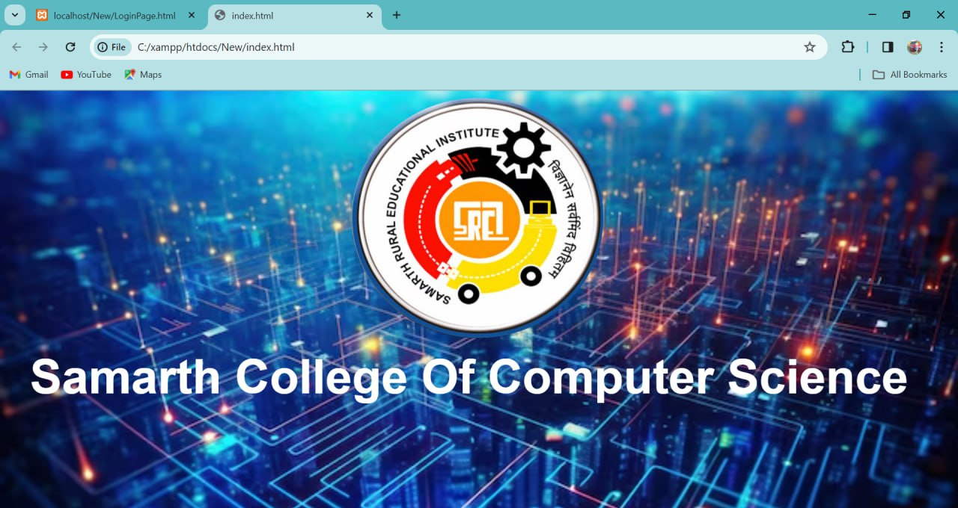

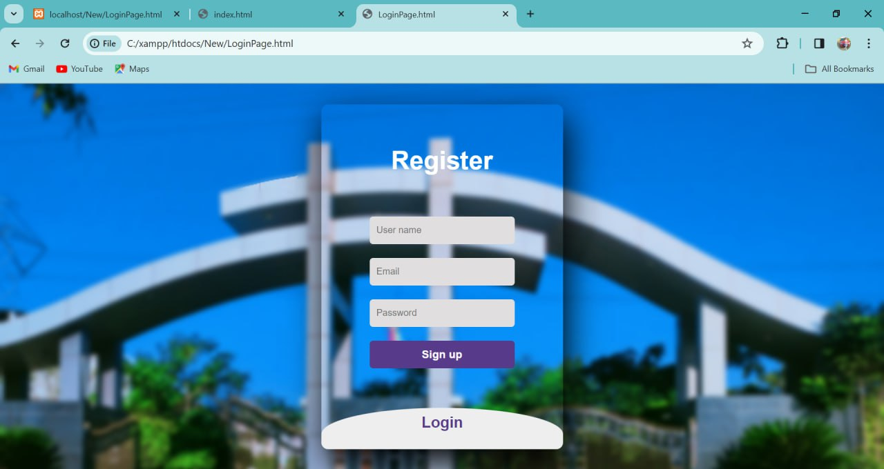

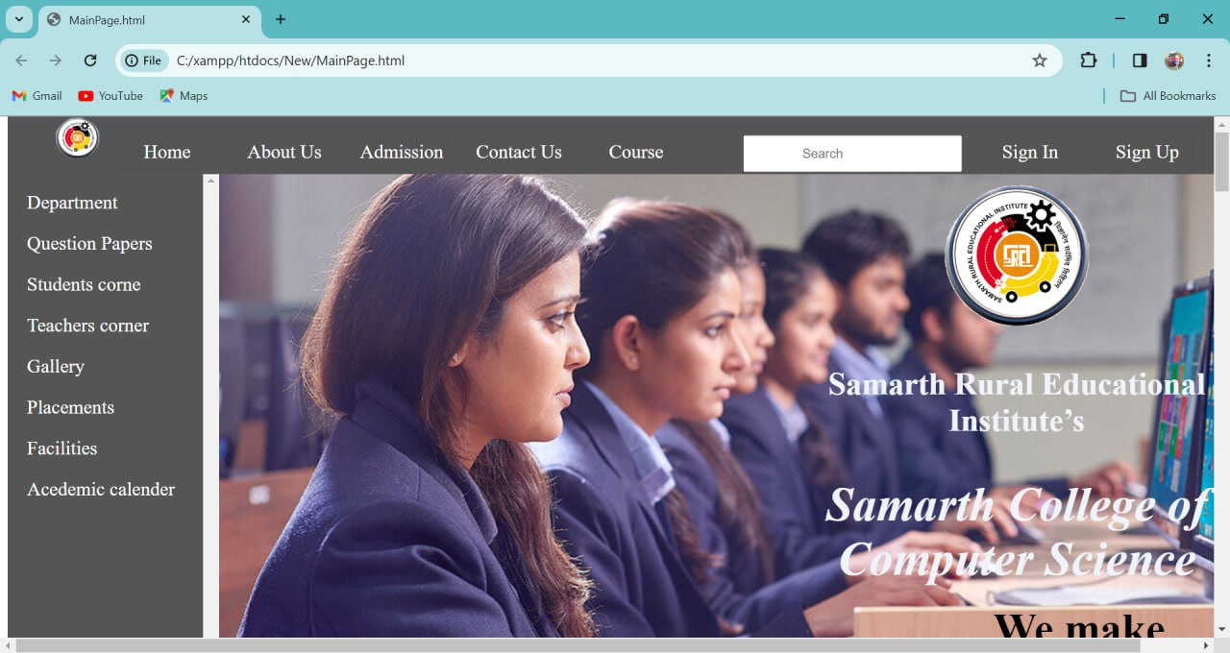

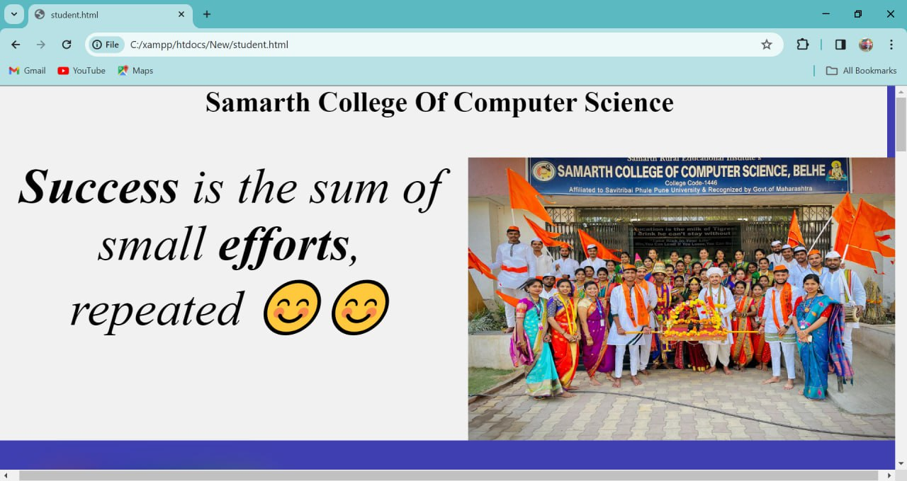

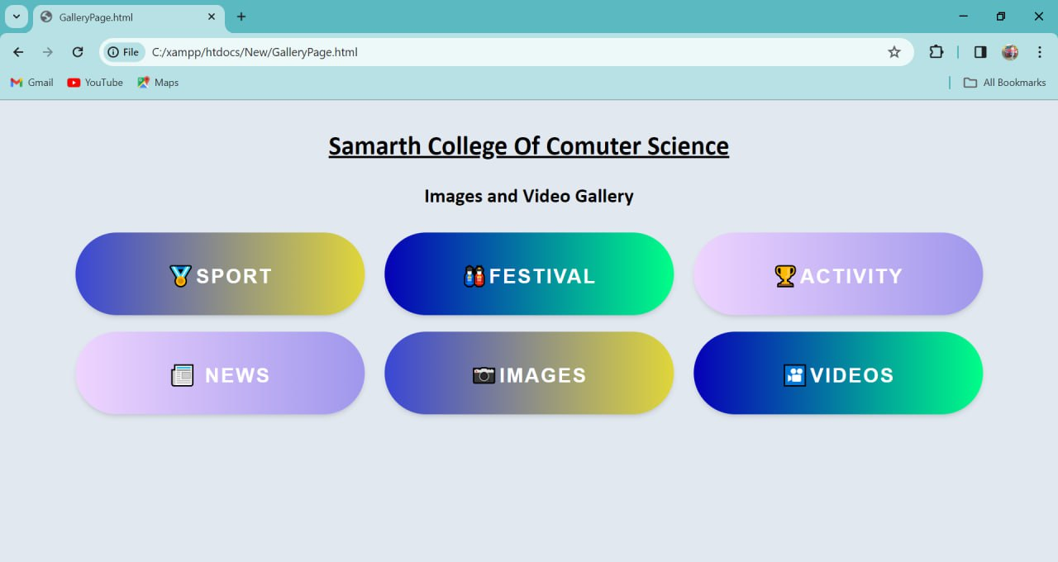

* + - 1. **Report Testing**

**Objective:**

The objective of this testing effort is to **validate the website login functionality** feature of the virtual assistant.

### Test Approach:

The testing will primarily focus on black box testing techniques to validate the website login and check the features from an end-user perspective.

### Test Environment:

Specify the test environment details including hardware, software, and any additional tools required for testing.

## Test Cases:

**Black Box Testing:**

**Homepage Navigation:**

Test Case 1: Verify that clicking on the college logo redirects the user to the homepage.

Test Case 2: Ensure that all navigation links on the homepage (e.g., About Us, Academics, Admissions) lead to the respective pages.

Test Case 3: Confirm that the homepage contains a search bar, and searching for keywords returns relevant results.

**Academics Section:**

Test Case 4: Validate that all academic programs listed on the website are clickable and lead to detailed program pages.

Test Case 5: Ensure that course descriptions, faculty information, and program requirements are accurately displayed for each academic program.

Test Case 6: Verify that links to academic calendars, course catalogs, and exam schedules are functional and up-to-date.

**Admissions Section:**

Test Case 7: Confirm that the admissions section provides clear instructions and guidelines for prospective students.

Test Case 8: Validate that downloadable application forms and admission deadlines are prominently displayed.

Test Case 9: Test the functionality of the online application portal, ensuring that users can submit applications successfully.

**Faculty and Staff Section:**

Test Case 10: Verify that faculty profiles are listed alphabetically and include relevant information such as qualifications, research interests, and contact details.

Test Case 11: Ensure that staff directories are organized by department or administrative unit and contain accurate contact information for each staff member.

**Campus Life Section:**

Test Case 12: Validate that information about campus facilities (e.g., libraries, sports facilities, dining halls) is up-to-date and includes operating hours and location maps.

Test Case 13: Confirm that extracurricular activities, clubs, and events are listed and include descriptions, dates, and contact information.

**Contact Us Section:**

Test Case 14: Verify that the contact information for the college (e.g., address, phone number, email) is accurate and easily accessible.

Test Case 15: Test the functionality of the contact form, ensuring that submissions are received by the appropriate department or individual.

**Responsive Design Testing:**

Test Case 16: Test the website's responsiveness across different devices and screen sizes, including desktops, laptops, tablets, and smartphones.

Test Case 17: Validate that images, text, and navigation elements adjust dynamically to fit smaller screens without loss of functionality or readability.

**Cross-Browser Compatibility:**

Test Case 18: Test the website's compatibility with popular web browsers such as Google Chrome, Mozilla Firefox, Safari, and Microsoft Edge.

Test Case 19: Ensure that the website displays consistently and functions correctly across different browsers, including older versions.

**White Box Testing:**

**Homepage Load Time:**

Test case: Measure the time taken for the homepage to load.

Expected result: The homepage should load within an acceptable timeframe (e.g., under 3 seconds) to ensure optimal user experience.

**HTML and CSS Validation:**

Test case: Validate the HTML markup and CSS stylesheets of the website.

Expected result: The HTML code should comply with W3C standards, and CSS stylesheets should be error-free and well-structured to ensure consistency and compatibility across different browsers.

**Internal Link Verification:**

Test case: Verify that all internal links on the website are functional and point to valid destinations.

Expected result: Clicking on internal links should navigate users to the intended pages within the website without encountering broken links or errors.

**Input Validation:**

Test case: Test input fields (e.g., forms, search bars) with valid and invalid data to ensure proper input validation.

Expected result: The website should validate user inputs effectively, providing appropriate error messages for invalid inputs and processing valid inputs correctly.

**Error Handling:**

Test case: Intentionally trigger errors (e.g., 404 not found, 500 internal server error) and verify the website's error handling mechanisms.

Expected result: The website should gracefully handle errors, displaying informative error messages and guiding users to appropriate actions or alternative pages.

### Test Execution:

Execute the test cases as per the defined test approach. Record the actual results for each test case.

**Test Results:**

Document the actual results for each test case, including any deviations or issues encountered.

# CONCLUSION:

In concluding the college website project, we reflect on the journey of envisioning, designing, developing, and deploying a digital platform that serves as the virtual gateway to our college community. Through collaborative efforts and dedication, we have achieved our goal of creating a dynamic, informative, and user-centric website that encapsulates the essence of our institution and enhances the digital experience for all stakeholders.

Our website serves as a comprehensive repository of information, providing prospective students with insights into our academic programs, admissions process, and campus life. For current students, faculty, staff, and alumni, the website serves as a hub for accessing resources, staying updated on events, and engaging with the college community.

# FUTURE SCOPE

# Looking ahead, the future scope of the college website project holds immense potential for further innovation, enhancement, and expansion. As we continue to adapt to the evolving needs and expectations of our college community, several key areas offer opportunities for future development and growth:

# Embrace emerging technologies such as artificial intelligence (AI), machine learning, and natural language processing to enhance the website's functionality and user experience.

# Explore the implementation of AI-powered chatbots, virtual assistants, and personalized recommendation engines to streamline user interactions, provide intelligent insights, and deliver personalized content.

# Foster greater engagement and interactivity among users through the incorporation of interactive features such as forums, discussion boards, and social media integration.

# Implement gamification elements, quizzes, and surveys to encourage user participation, collaboration, and community building within the college ecosystem.

# Consider the development of a dedicated mobile application complementing the website, providing users with on-the-go access to essential college information, services, and resources.

# Leverage mobile app technology to enhance communication, collaboration, and engagement among students, faculty, staff, and alumni.

# Utilize data analytics tools and techniques to gain insights into user behavior, preferences, and trends, enabling data-driven decision-making and personalized user experiences.

# Implement dynamic content delivery mechanisms, adaptive interfaces, and personalized recommendations based on user data to enhance engagement and satisfaction.

# Expand the scope of content and services offered on the website to encompass a broader range of topics, resources, and functionalities relevant to the college community.

# Introduce new sections, features, and resources focusing on career development, alumni networking, research initiatives, and community outreach to enrich the user experience and meet diverse needs.

# Prioritize accessibility initiatives to ensure that the website remains inclusive and accessible to users of all abilities.

# Continuously evaluate and enhance accessibility features, usability guidelines, and assistive technologies to promote equal access to information and services for all users.

# REFERENCES AND BIBILOGRAPHY

**Websites Referred**

* [www.stackoverflow.com](http://www.stackoverflow.com/)
* [www.codecademy.com](http://www.codecademy.com/)
* [www.tutorialspoint.com](http://www.tutorialspoint.com/)
* [www.google.co.in](http://www.google.co.in/)

## YouTube Channels referred

* Apna College.